C.T.C.A. PRESCHOOL SUPPLY LIST
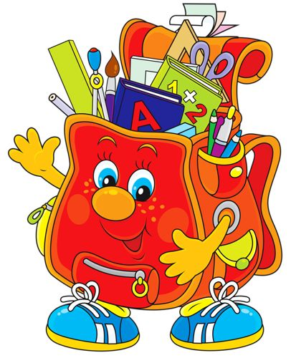

Toddler Supply List
(1)Art Box
(1) My First Crayons (Crayola)
(1) Jumbo Glue Stick
(1)Crayola Washable Paint 6 count
(1) Crayola Construction Paper
(4) boxes of Kleenex
(2) bottles of hand sanitizer
(2) bottles of soft soap
(1) 2 inch Mat
(2) Folders w/pockets
(1) Change of Clothes
(1) Box Gallon Zip-loc Bags
(2) Lysol Wipes
(1) Art Smock or Long Sleeve Plastic Bib-used for art and lunch to preserve uniform
(1) *Back Pack*

Bolded items are considered community items and will not be returned
Required if needed:
Pampers/Pull-Ups
Wipes
Vaseline/Diaper Cream
*Check w/your teacher
Bottles are not permitted

Pre-K 2 Supply List
(1) Art Box
(2) My First Crayons (Crayola)
(1) pack of Kindergarten (fat) pencils without erasers
(1) 1 pack of flat erasers
(2) Glue Sticks
(1) Crayola Washable Paint 6 count
(1) Pack of paint brushes
(1) Crayola Construction Paper
(2) Lysol Wipes
(4) boxes of Kleenex
(2) bottles of hand sanitizer
(2) bottle of soft soap
(1) 2 inch Mat
(2) Large bath towels for nap or
(1) nap mat
(2) Folders w/pockets
(1) Change of Clothes
(1) Box Gallon Zip-loc Bags
(1) Art Smock or Long Sleeve Plastic Bib- used for art and lunch to preserve uniform if needed
(1) *Back Pack*

*2 Inch Mat may be purchased at Knowledge Tree
Knowledge Tree-2095 Exeter Road, Germantown TN, 38138 (901) 758-2280
Knowledge Tree-8195 Dexter Road, Cordova TN, 38016 (901) 382-3101
Knowledge Tree- 5000 Summer Avenue, Memphis TN, 38122 (901) 324-9251
Knowledge Tree-981 Goodman Road W, Horn Lake MS, 38637 (901) 510-5601

Pre-K 3 Supply List
(1)Art Box
(3) 24 Crayola Crayons
(2) Glue Sticks
(2) Liquid Glue
(1) Crayola Washable Paint 6 count
(1) pack of paint brushes
(1) Pack of kindergarten (fat) pencils without erasers
(1) Pack of flat erasers
(1) Safety Scissors
(4) Boxes of Kleenex
(2) Bottles off hand sanitizer
(2) bottles of soft soap
(1) 2 inch Mat
(2) Large bath towels for nap
Or
(1)nap mat
(1) change of clothes
(3) Folders w/pockets
(2) Boxes Gallon Zip-loc Bags
(1) Art Smock or Long Sleeve Plastic Bib-used for art and lunch to preserve uniform if needed
(1) *Back Pack*

Pre-K 4 Supply List
(1)Art Box
(2) 24 Crayola Crayons
(2) Glue Sticks
(2) Liquid Glue)
(1) Crayola Washable Paint 6 count
(1) Pack of paint brushes
(2) Packs of Kindergarten (fat) pencils without erasers
(1) Pack of flat erasers
(1) Safety Scissors
(1) Ruler
(4) Boxes of Kleenex
(2) bottles of hand sanitizer
(2) bottles of soft soap
(1) 2 inch Math
(2) Large bath towels for nap
Or
(1)nap mat
(2) Folders w/pockets
(1) change of clothes
(1) Box Gallon Zip-loc Bags
(1) Art Smock or Long Sleeve Plastic Bib- used for art and lunch to preserve uniform if needed
(1) *Back Pack*

